# Overview

The Energy Service Provider (ESP) offers its customers competitive pricing for their energy commodities and customer services. This “offering” is commonly referred to as a “Product.” Products are typically customized to meet the consumer’s needs and frequently change to stay competitive. Products offered to Residential Customers are typically different from those offered to Commercial Customers, generally due to volume differences. Products also differ based upon Utility Territories and Markets served due to the differing Utility Tariffs and Market rules.

Products are comprised of several components. At its most basic level, a product defines the commodity and/or service(s) being offered along with its price and calculation method used to arrive at the charges billed to the customer. This level is referred as the Rate Package (aka Rate Detail). At a more complex level, a Product is further comprised of business rules that determines availability (to whom, which Utility and Market, and when) along with other specific business conditions in support of the product.

## Rate Package Overview

The creation of a Product begins with creating a “**Rate Package**.” A Rate Package consists of charges that are routinely billed to a customer each month. The Rate Package determines what and how services are charged to the Customer. A Rate Package consists of one or more “**Rate Details**.” A Rate Detail consists of:

1. **Rate Description** – Description of the Charge used by the ESP to bill a Customer. Examples of Rate Descriptions:
   1. Energy Charge
   2. Monthly Meter Charge
   3. City Taxes
   4. County Taxes
   5. NSF Charge
   6. Late fee
2. **Rate Type** – the calculation method for a given Rate Description. Examples of Rate Types:
   1. Fixed
   2. Variable
   3. Indexed
3. **Rate Category** – Used to organize multiple Rate Descriptions together under a “Category” for the purposes of displaying the charges on the Customer’s Invoice and within the AR Tab on the Customer Summary screen. Examples of Rate Categories:
   1. Energy Charges
   2. Utility Pass-through Charges
   3. Taxes
   4. Miscellaneous Charges
4. **Effective Date** – Begin date for the rate detail
5. **Expiration Date** – End date for the rate detail
6. **Rate Amount** – Charge amount of the rate detail

The Customer’s assigned Rate Package is visible on the Customer Summary screen in the Billing Information section of the Customer Info tab in a field called “Rate Code.”

## Product Overview

As mentioned previously, Products are comprised of business rules that determine to whom the product is available. Below is a list of typical Business Rules that are included in the Product:

1. **Business Division** – Business Entity of the ESP offering the Product
2. **Customer Type** – Residential or Commercial
3. **Commodity Type** – Gas or Electric
4. **LDC Rate Class** – Customer Service Class assigned by Utility
5. **Offering Period** – Begin and End date for Product Offering
6. **Terms** – Length of Contract
7. **Cancellation Fees** – Charges associated if contract is terminated early
8. **Rollover Product** – Product used for billing at end of contract period
9. **Special Offers** – Promotional offers
10. **Documents -** customer documents sent upon the enrollment of a product
11. **Commissions** – sales channel commissions associated to the product

Fundamental to ***ista***|NET is Customer billing. In order for billing to occur the Customer must receive from the Utility monthly consumption for their commodity being served and have a current Product assigned for that commodity. This means that the proper management of Products and their assignment to the Customer is crucial.

Initially, Products are assigned to Customers during the enrollment process. Subsequently, Customer renewals and product changes are managed within the Customer’s account in the Customer Summary screen. In order for either of these methods of assignment to occur, Products have to be configured in the system prior to assignment. To make the administration of Products more efficient, ***ista***|NET has four options available for creating and managing Products. Listed below are the options ranging in order from very simple (Rate Details) to more complex (Products). *NOTE: Only one of these Administration features can be used in the application at a time.

1. **Client Rate Administration** – one link where only a Rate Package is created
2. **Rate Administration and Product Administration** – two links, Rate Admin page creates the Rate Package and the Product Admin page creates the Product
3. **Client Product Rate Administration** – one link combines the two features together into one page Rate Package and Product
4. **Rate Package and Product Management** – one link that combines Rate Packages and Products together, but has more robust features available

The remainder of this User Guide includes instructions on all four administration tools available for managing Products and Rate Packages. Proceed to the Administration Tool that is featured in your application for specific instructions.

# Client Rate Administration

This process uses one link - Rate Administration page creates the Rate Package. There is no associated Product.

## Creating Rate Packages

To start the process, click on the ***Client Rate Administration*** link from the Administration Menu Tab. The result will take you to the Rate Administration page where you will see two buttons labeled:

1. *New Rate*
2. *Search*

Click the New Rate button to open a new Rate Package Template.

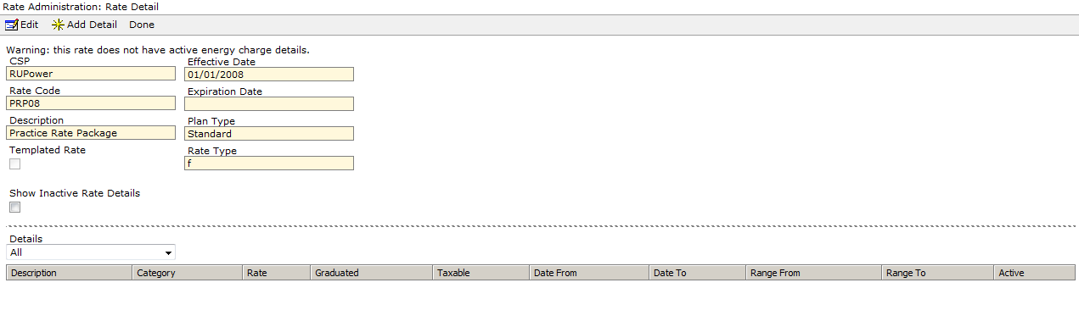

In Step 1, you are defining the Rate Package details to be offered:

1. Description
2. Effective Dates
3. Rate Type – calculation method

In Step 2, you are adding Charge Details (Rate Details). Click on the Add Detail button to open the Charge Detail Template. Select the appropriate Charge Category, Charge Description and Unit of Measure. The Charge Type selected will determine whether or not any additional fields are required to complete the process.

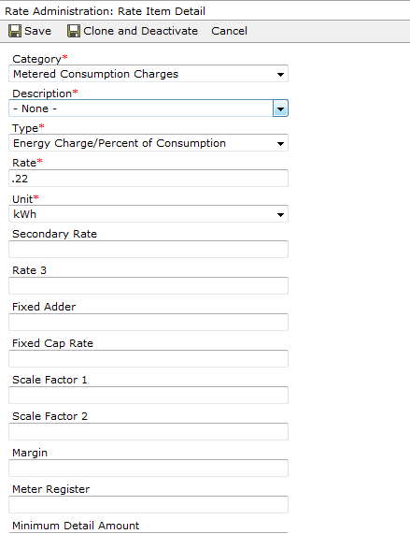

In Step 3, review the details. To make any changes, click on the Edit button and make appropriate changes. When finished, click on the Done button. If more than one Charge Detail is needed repeat Step 2. When all Charge Details are added, click on the Done button to go back to the Rate Administration page.

# Rate Administration and Product Administration

This process uses two links - Rate Administration page creates the Rate Package and the Product Administration page creates the Product.

## Creating Rate Packages

To start the process, click on the ***Client Rate Administration*** link from the Administration Menu Tab. The result will take you to the Rate Administration page where you will see two buttons labeled:

1. *New Rate*
2. *Search*

Click the New Rate button to open a new Rate Package Template.



In Step 1, you are defining the Rate Package details to be offered:

1. Description
2. Effective Dates
3. Rate Type – calculation method

In Step 2, you are adding Charge Details (Rate Details). Click on the Add Detail button to open the Charge Detail Template. Select the appropriate Charge Category, Charge Description and Unit of Measure. The Charge Type selected will determine whether or not any additional fields are required to complete the process.



In Step 3, review the details. To make any changes, click on the Edit button and make appropriate changes. When finished, click on the Done button. If more than one Charge Detail is needed repeat Step 2. When all Charge Details are added, click on the Done button to go back to the Rate Administration page.

## Creating Products

To create a new Product, from the Product Administration link, click on the New Product button.



The Product Detail screen will appear where you define the Product. Select and enter all appropriate details. This step includes the assignment of the Rate Package to the Product. Click on the Save button to save your entry.

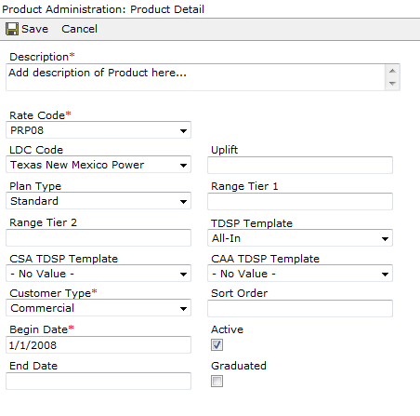

#### Bulk Product Updates

This link has an added feature that allows you to make updates to multiple products using the Bulk Product Update functionality. The updates that are allowed include changing the Product’s Active Flag and the Customer Type. To perform an update, click on the Bulk Product Update link available from the Product Administration page.

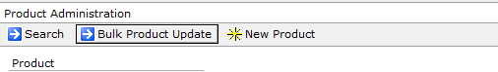

The result will take you to the Product Bulk Update screen where you will choose multiple Products for which the change is to be made. The steps are as follows:

1. Select your Products using the Product Filter to assist you in finding your Product(s) more easily. Enter all or part of the Product name and click on the Search Button.
2. Once you have found the appropriate Products, place a check in the box to the left of each product that needs to be updated.
3. Change the Customer Type and/or Active Flag, depending upon the type of change you are making.
4. Click on the Update button to process the changes.

In the example below, the Products are being updated to an Inactive Status, meaning they will no longer be available.

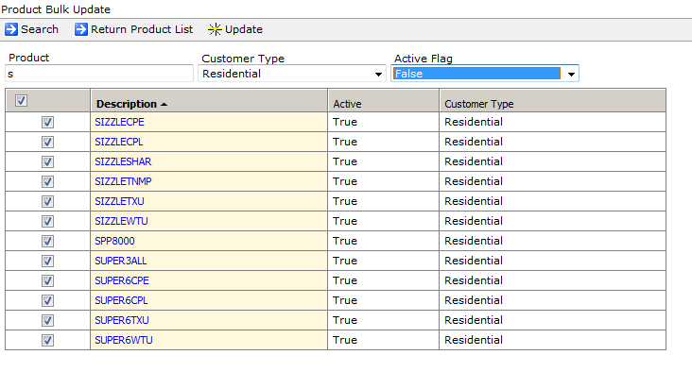

Once you have confirmed the changes are correct, click on the Return Product List button to go back to the Product Administration Page.

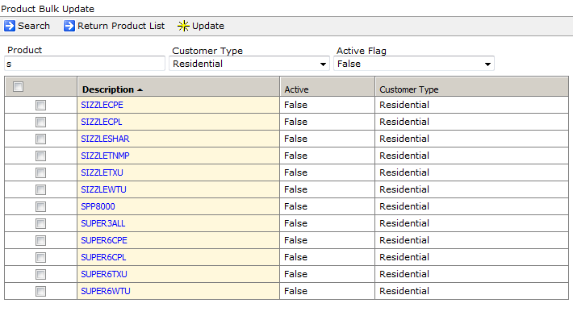

# Client Product Rate Administration

## Creating Rate Packages and Products

The ***Client Product Rate Administration*** containsone link that combines the two features together into one page - Rate Package and Products. To start the process, click on the ***Client Product Rate Administration*** link from the Administration Menu Tab. The result will take you to the Rate Administration page where you will see two buttons labeled:

1. *New Rate*
2. *Search*

Click the New Rate button to open a new Rate Package Template.

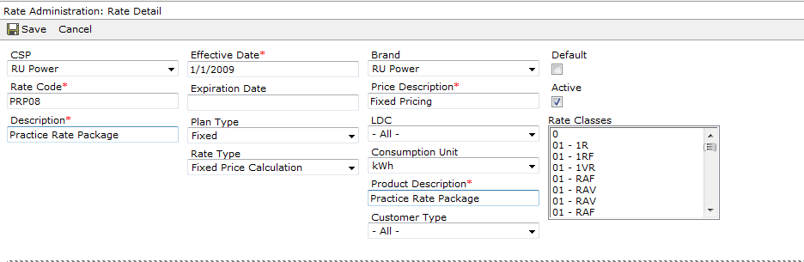

In Step 1, you are determining to whom the Rate Package and Product will be offered and giving it a description.

1. Description
2. Effective Dates
3. Rate Type – calculation method
4. Consumption Type
5. Business entity where applicable
6. LDC where applicable
7. Customer type where applicable

In Step 2, you are adding Charge Details (Rate Details). Click on the Add Detail button to open the Charge Detail Template. Select the appropriate Charge Category, Charge Description and Unit of Measure. The Charge Type selected will determine whether or not any additional fields are required to complete the process.

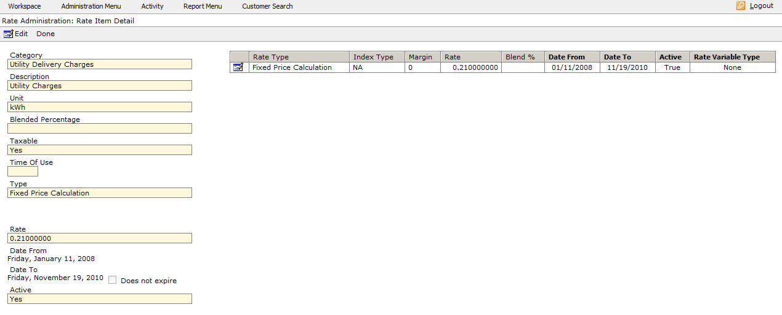

In Step 3, review the details. To make any changes, click on the Edit button and make appropriate changes. When finished, click on the Done button.

If more than one Charge Detail is needed repeat Step 2. When all Charge Details are added, click on the Done button to go back to the Rate Administration page.

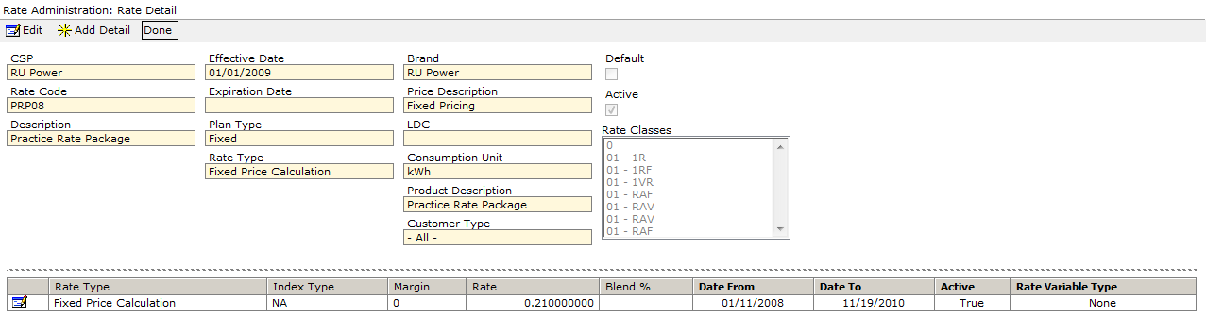

# Rate Package and Product Management

## Creating Rate Packages

The ***Rate Package and Product Management*** feature contains one link that combines rates and products together, but has more robust features available. To create a Rate Package, select the ***Rate Package and Product Management*** link from the Administration Menu Tab. The result will take you to the Administration page where you will see two tabs labeled:

1. *Rate Package Management*
2. *Product Management*

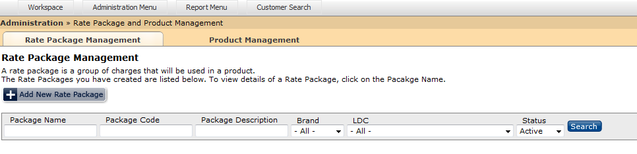

The process begins with creating the Rate Package. From the Rate Package Management tab Click on the Add New Rate Package to open a new Rate Package Template.

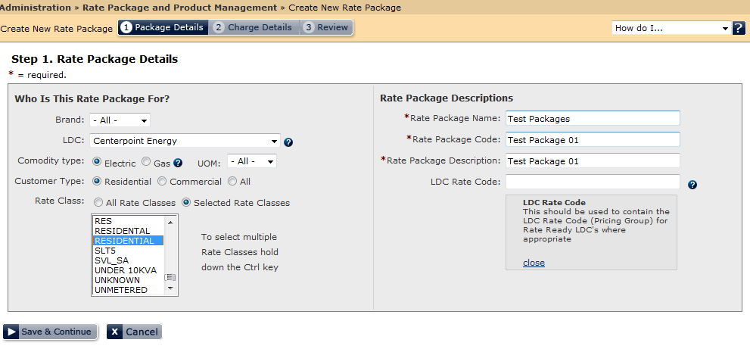

In Step 1, you are determining to whom the Rate Package will be offered and giving the Rate Package a description. Depending upon the ESP, the field selections will vary according to their specific Business Rules. Complete all fields and click on the Save & Continue button to go to the next Step.

In Step 2, you are adding Charge Details (Rate Details). Click on the Add Charge Detail button to open the Charge Detail Template. Select the appropriate Charge Description and Unit of Measure. The Charge Type selected will determine whether or not any additional fields are required to complete the process. If more than one type of charge is required, click on the **Save and** **Add More** button to add additional charges. When finished, click on the Save button to go to the final step.

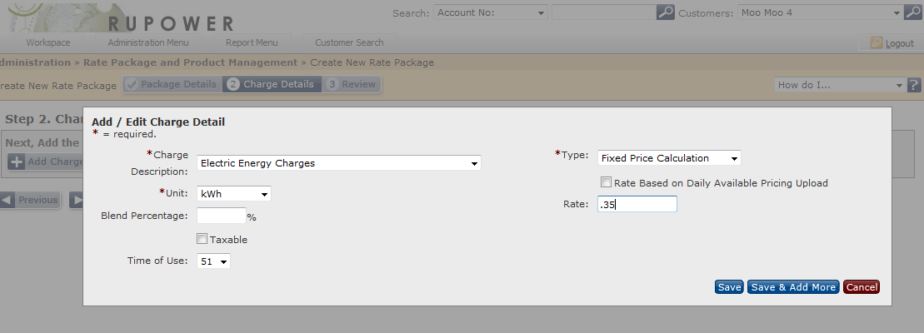

In Step 3, you review the Rate Package Details and make any changes before you complete the process. Once you click on the **Finished** button, you will not be able to change any of its details.

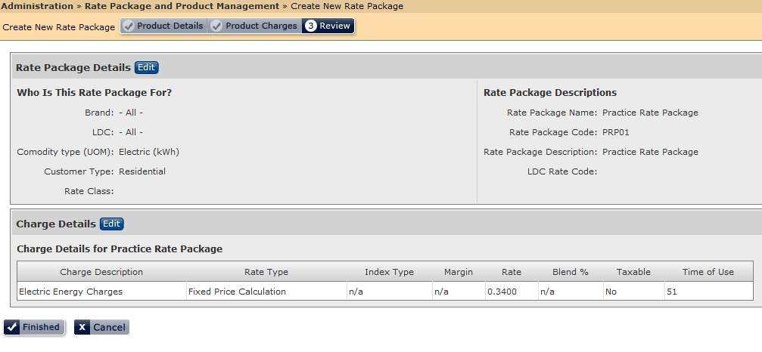

## Creating Products

To create a new Product, from the Product Management Tab, click on the Add New Product button. The Product Details screen will appear where you define the Product.

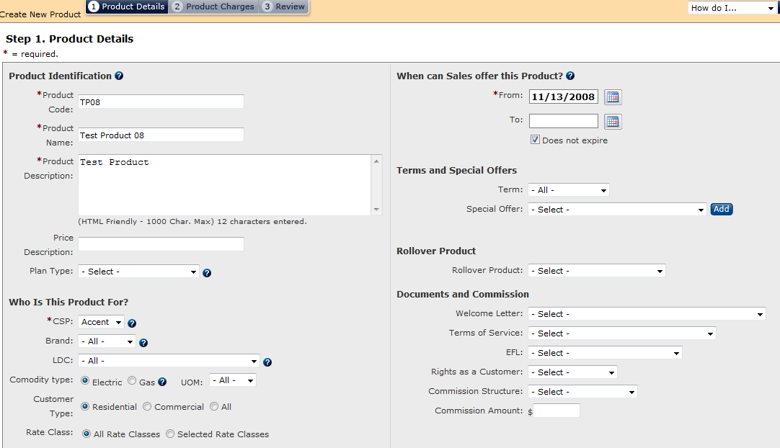

**There are three steps to creating the Product:**

1. Product Details
2. Product Charges
3. Product Review

**Step 1 – Product Details:**

To assist you in the completion of the Product, below is a list of fields and a description of their purpose. NOTE: Any field marked with a “*” is a required field.

**Product Identification:**

1. **Product Code:** (For Internal Use) you will use this code to locate and assign this product
2. **Product Name:** (Public Use) this name will be displayed to the customer when they make their product selection and also may appear on their invoices
3. **Product Description:** (Public Use) this description outlines the details of the product and helps your customer decide what product to select
4. **Price Description:** user-defined field to describe the price associated with the product
5. **Plan Type** - user-defined field to categorize the Product

**Who is this Product For?**

1. **CSP** – Energy Service Provider offering the Product
2. **Brand** –Business branding under which the Product will be offered
3. **LDC** – Utility Territories where the Product is offered
4. **Commodity Type** – Gas or Electric
5. **UOM** – Unit of Measure for the Product
6. **Customer Type** – Commercial Residential
7. **Rate Class** – Utility-assigned Rate Class

**When can Sales offer this Product?**

1. **From** – Begin Date for the offering
2. **To** – End Date for the Offering
3. **Does not expire** – allows the End Date to be blank

**Terms and Special Offers**

1. **Term** – length of time the product is available without change
2. **Special Offers** – List of **Special Offerings or Promotions** that go with this Product

**Roll Over Product**

1. **Rollover Product** – At the end of the Product’s Term, this is the Product that the Customer will automatically roll to for continued billing purposes

**Documents and Commissions**

1. **Welcome Letter** – choose from the list the specific Welcome Letter to be sent to Customers on this Product
2. **Terms of Service (TOS)** - choose from the list the specific TOS to be sent to Customers on this Product
3. **Electricity Facts Label (EFL)** - choose from the list the specific EFL to be sent to Customers on this Product
4. **Rights as a Customer** - choose from the list the specific Rights as a Customer to be sent to Customers on this Product
5. **Commission Structure** – choose from the list the Sales Channel associated with this Product
6. **Commission Amount** – enter the commission rate “$” to be paid to the Sales Channel for this Product

Once the Product Details are entered, click on the Save and Continue button to go to Step 2 for Product Charges. To assist you in the completion of Step 2, below is a list of fields and a description of their purpose. Note: Any field with a “*” is a required field.

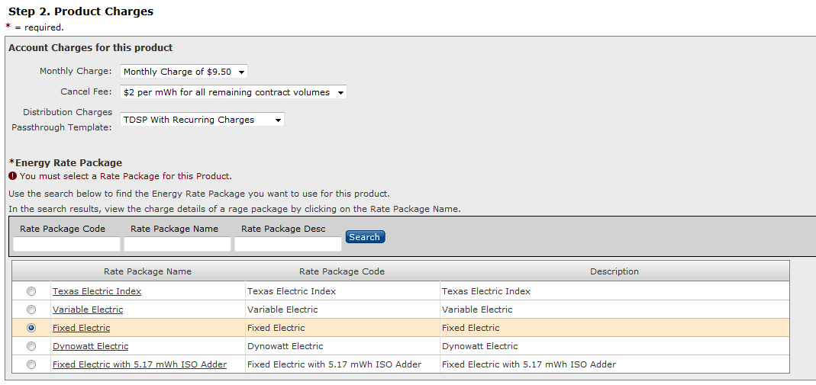

**Step 2 - Product Charges**

1. Select appropriate **Account Charges** for this Product, if any.
2. Select Energy Rate Package – these are the rate details associated to the Product. Click on the search button and select the appropriate Rate Package. Click Save and Continue button to complete the process.

**Step 3 – Review**

1. Review all the details and if finished, click the ***Finish*** button to complete the process.

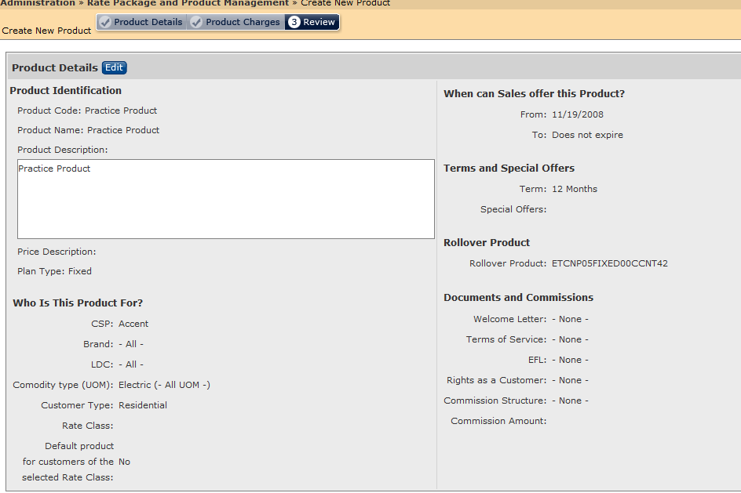

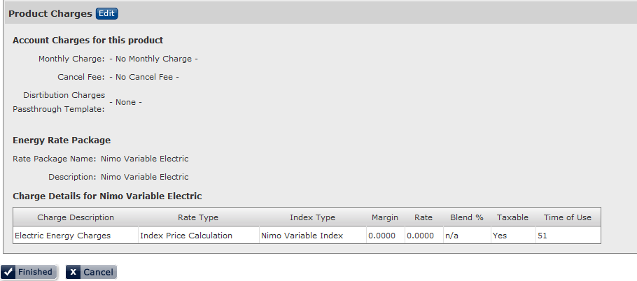

# Ancillary Activities of Rate and Product Administration

In addition to establishing Products and Rate Packages, there are several other ancillary activities to ensure accurate billing. These activities include:

1. **TDSP Matrix Administration** – template for determining which TDSP/LDC charges are passed through to the customer in Supplier Consolidated billing models.
2. **Rate Index Range Maintenance** – Table of Indices that determines the rate for a customer for a given time period.
3. **Aggregator Maintenance** – Table of Sales Channels that are paid a commission for their sales efforts.
4. **Rate Ready Rate Change** – Rate submittal functionality for customers being served in Rate Ready markets. Allows you to submit a Rate to the LDC so that the customer can be billed correctly.
5. **Contract Volume Management** - A Block Price rate calculation compares the consumption (actual usage) against the contract volumes (expected usage). The Customer’s contracted volumes are managed from their Customer Summary screen.

## TDSP Matrix Administration

In markets where the billing type is Supplier Consolidated, LDCs send an 810 Invoice for their utility charges. Whether or not these charges are passed on to the Customer is determined by the TDSP Matrix assigned to the Customer’s service location.

Client Matrices are created during their initial implementation process and new Templates are created by ista as needed. While the name of a Matrix is determined by the ESP and varies accordingly, how the Matrix functions is the same across all Clients. Maintenance of existing Matrices is the responsibility of the Client and the task is performed using the ***TDSP Matrix Administration*** user interface.

To access the Matrix Administration screen, click on the ***TDSP Matrix Administration*** link located on the Administration Menu page. The result will display the initial page. Choose the TDSP Template type from the drop down list and click on the Load Button.

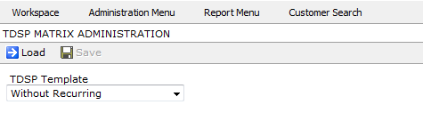

The result will display a Matrix that list all possible LDC/TDSP charges in the left-hand column, and each LDC/TDSP served by ista is listed in the right-hand columns. Placing a ***Check*** in the box of a specific Charge for a specific LDC indicates that the charge WILL BE passed on to the Customer during billing. If the box is left ***Blank***, the Charge will NOT be passed on during billing. Once you are finished with changes, click on Save to save you entries.

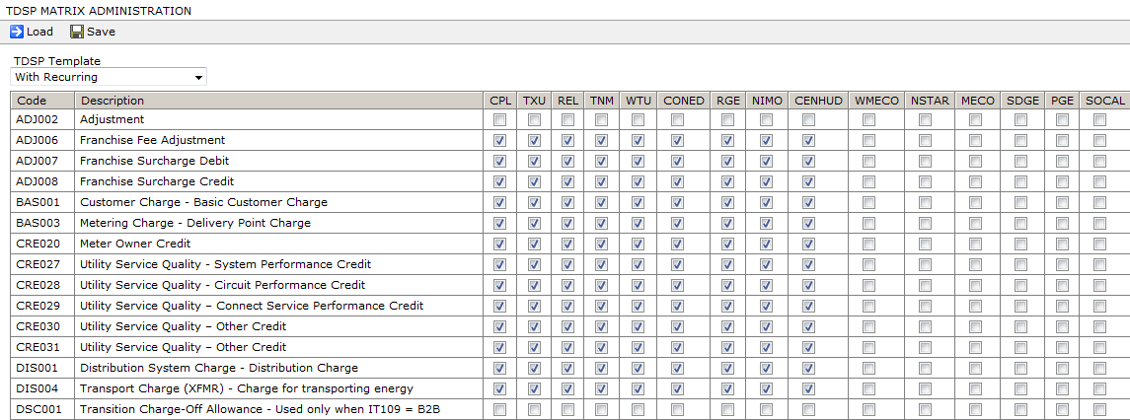

## Rate Index Range Maintenance

For Rate Types that use an Index, Index maintenance is required. Some indices are managed via Web Services and others are managed manually. The Manual maintenance activity is performed using the Rate Index Range Maintenance user interface. To access the page, click on the ***Rate Index Range Maintenance*** link from the Administration Menu.

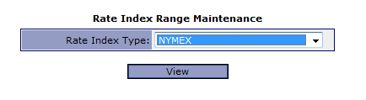

Select the appropriate Index and click on the View button. The result will display the Index table with and Add button where you can add new entries or edit existing ones.

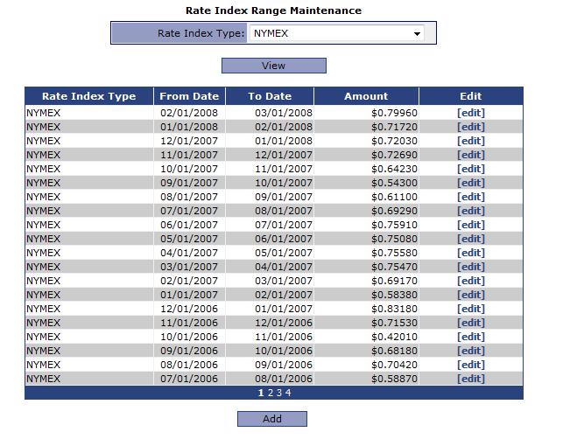

To **Add** a new entry, click on the Add button. Select the appropriate ***From Date and To Date***, enter the ***Amount*** and click on the ***Save*** button to save your entry. *NOTE: when entering values for an index, the date to and date from of consecutive entries MUST BE THE SAME DATE.

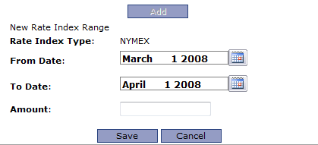

To **Edit** an existing Index Rate Amount, click on the **[edit]** link of the line item to be changed. Change the amount and click on the **[save]** link to save your entry.

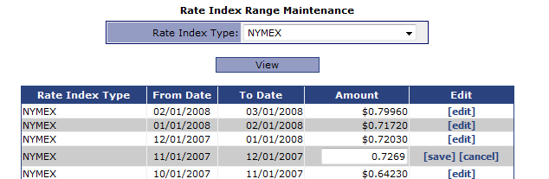

## Aggregator Maintenance

Sales Channels (aka Aggregators) are used in the deregulated markets for the purpose of selling energy services on behalf of the ESP. They are typically paid a commission for their sales efforts. ***ista***|NET provides a table for tracking the Sale Channels used by the ESP.

The Aggregator Maintenance table allows you to add a new Sales Channel and edit existing ones. To access the Aggregator Maintenance user interface, click on the ***Aggregator Maintenance*** link available from the Administration Menu. The result will display the Aggregator Table containing existing Sales Channel records.

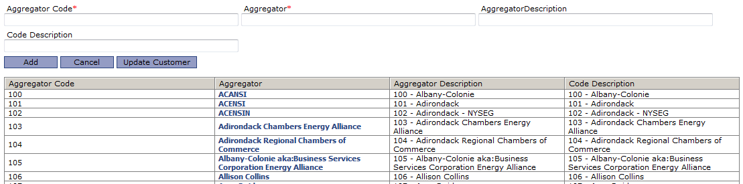

To add a new Sales Channel, click on the Add button and enter the appropriate data. Click the Add button to save your entry.

To modify an existing Sales Channel, click on the Aggregator name and make the appropriate changes. Click on the Update button to save your entry.

To update a customer’s record with a new Sales Channel, click on Update Customer. Enter the Customer’s account number. Place a check in the box next to the appropriate Sales Channel(s) and click on the Add button to save your entry. Edit the Commission rate, Dates and term in appropriate fields. Click on Done when finished to save your entry.

